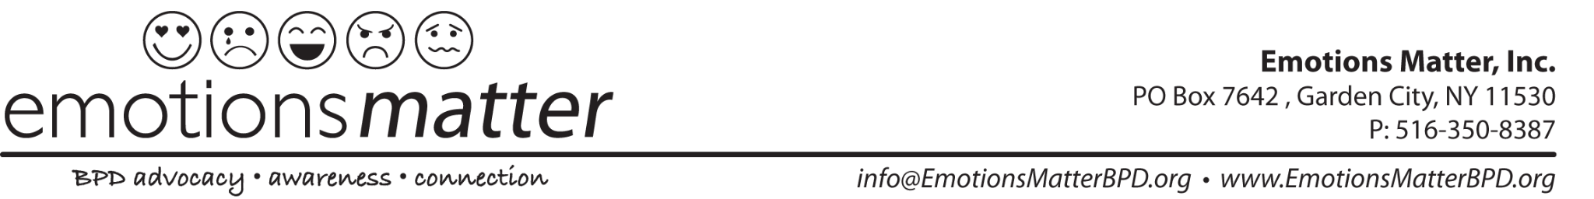

Step by Step Instructions to Submit a Letter for CA AB 1412 (Hart) Pretrial Diversion Bill for Borderline Personality Disorder

- Download and Update the Emotions Matter, Inc. Letter Template by customizing all highlighted areas. The template can be found here: (INSERT LINK)

- Once the letter is updated, download the updated/customized template to your computer.

- Go to the California Position Letter Portal: https://calegislation.lc.ca.gov/Advocates/

- Create an account- You will find this at the bottom right corner of the Sign In Section
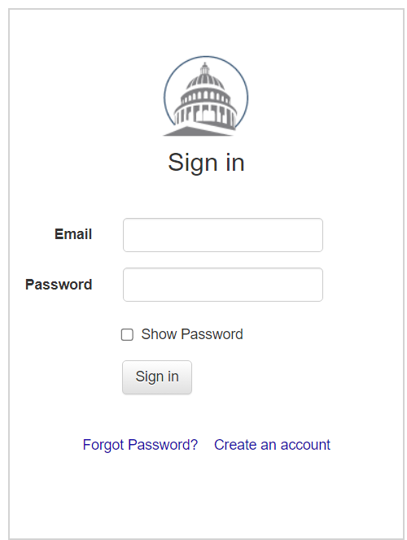
- Answer the Registration Questions. Here is how to answer registration questions:
REGISTRATION STATUS: Are you a registered lobbyist? Answer: NO
ORGANIZATION STATUS: Do you represent an organization, registered or otherwise?
Answer NO- if you are representing yourself
Answer YES- If you are from an organization
ORGANIZATION DETAILS: Enter- Emotions Matter and click “Emotions Matter Inc.” when the drop down appears.

- Click “Proceed”

- Fill out your personal information and choose your password security question and answer.

- Click “Register”

- After your registration is complete, you will be sent an email (to the email address you used to register) with your username and temporary password.

- Go back to the browser with the California Legislature Portal or go back to the website: https://calegislation.lc.ca.gov/Advocates/ , type in your username (email address) and copy/paste the temporary password from the email you just received.

- Create your own password once you are brought to the account setup page. Follow the instructions for your password and click “Change Password”

- Welcome to your activity homepage- You are now ready to submit your letter.

- In the Select a Bill section, Measure is AB. Type in 1412. Keep the Session Type as Regular.
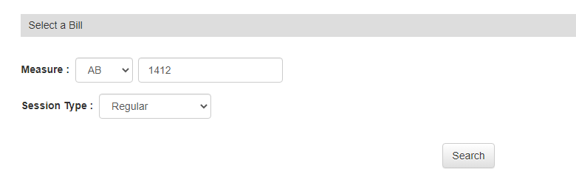
- Click “Search”

- This should pop up once you hit search:
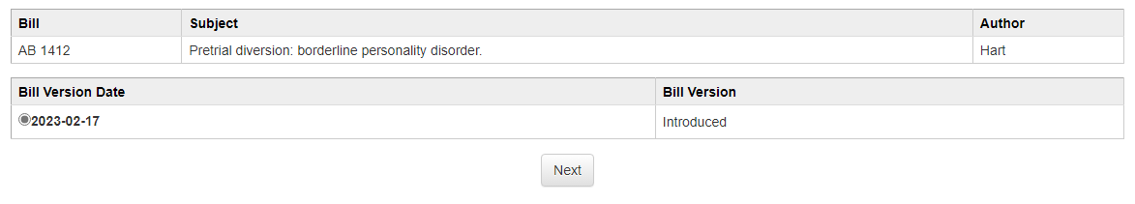
- FOR STANCE: Click “Support”

- Click Submit a letter instead
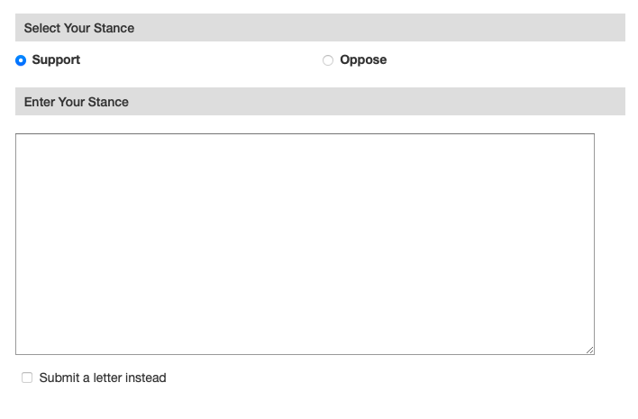
- Select “NO” if representing yourself to “Do you wish to represent an organization?”

- Under Letter Section: Choose the file (letter template you just customized and downloaded) you wish to download.

- Click “Submit”.

- Click on this https://forms.gle/ePY1tADsy5c2fySAA to inform Emotions Matters and National Education Alliance for Borderline Personality Disorder to let us know that you completed the form.

