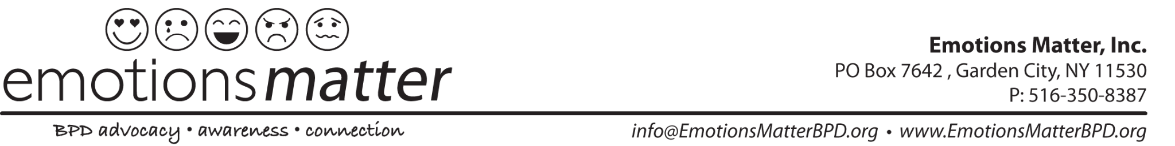

Step by Step Instructions to Submit a Letter of Support for HRJ0030 Resolution to Declare May BPD Month in Illinois

- Download and Update the Emotions Matter, Inc. “Draft Letter Resolution” Template by customizing all highlighted areas.

- Once the letter is updated, download the updated/customized template to your computer.

- Open the “IL House of Representatives Mental Health Committee” Excel spreadsheet and locate the emails of the house representatives on the mental health committee.

- Compose an email and paste BPD Month Resolution HJR0030 IL HR Mental Health Committee as the subject line

- Copy and paste the emails listed next to each representative and list them as BCC (see below)

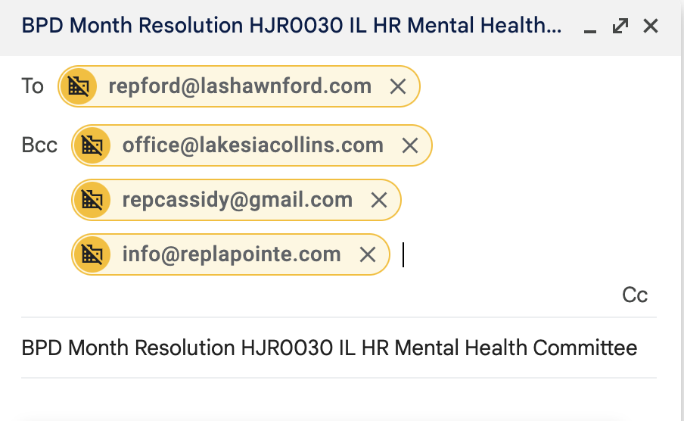
- In the body of your email, please state your name, City/County/State, and short description of the attachments you are sending.

- In the attachments, include the following:
    - The Emotions Matter, Inc. “Draft Letter Resolution” Template that you’ve edited with your information

    - The BPD Resolution Draft titled: “BPD LRB Draft”

    - The Illinois Info Sheet with Information about BPD

- Click on this link https://docs.google.com/forms/d/e/1FAIpQLSdCWjUFtr_L8PY7C6-sgnXY-CWx0f2hudcAgbvnUaCZqkP4lQ/viewform?usp=sharing to inform Emotions Matters and National Education Alliance for Borderline Personality Disorder to let us know that you sent an email in support of the Illinois Resolution to declare May as BPD month.

- Celebrate! Thank you so much for your support in our advocacy efforts in Illinois!

